ANNUAL GENERAL MEETING
20 April 2024, 6pm
Held at the Fireshed, 322 Greenwood Rd, Murrumbateman
FINAL MINUTES

Note
The meeting was interrupted twice with ACTIV alerts going off: throughout the room: once for what turned out to be a large bonfire on Scrubby Lane, Murrumbateman, the second for a hazard reduction burn in Bookham. No members were called out.
Attendance: 49 – 37 ordinary and probationary members, 12 residents, supporters & other guests
Apologies: 16 – 13 members, 3 guests.
Proxies: 8
Present: | Members (37):  Kim Bannan, Jordan Bartter, Dave Beattie, Scott Burrows, Stuart Burrows, Joanne Byrnes, Peter Clark, Shirley Clark, Patricia Duzevich, Ric Duzevich, Saan Ecker, Gareth Ellem, Tibor Fekete, Caitlin Fillingham, Kane Fillingham, Shaun Fletcher, Michael Georgevski, Laeli Hogan, Sally Kaufmann, Peter Kemmis, Darko Kukic, Suzanne Lavender, Mac MacDonald, Neville McMartin, Dave Morton, Gertraud Norton, Mark Norton, Glenn Odlum, Karolyn Odlum, Tarlo Odlum, Kaliyah Odlum, Joanne Reid, Liz Sage, Troy Searles. Sonia Slattery, John Storey, Meredith Thomas.  Residents/supporters/other guests (12):  Heather Bartter, Georgie Lorenz, Andrew Sage, Fiona Wholohan, George Fodes  G4 captain: Ron Hardy  Gundaroo Brigade: David Robinson (captain), Brett Southwell (deputy)  Sutton Brigade: John Cooper (captain), Vikki Bingley (senior deputy)  Murrumbateman Brigade: Richard Alley (captain)  RFS STZ: Mitchell Butler
Apologies: | Members (13):  Sandra Burrows, Shanelle Burrows, Steven Burrows, Rosie Catton, Damien Eggins, Kylie Eggins, Natalie Fletcher, Judy Hancock, Peter Johnson, Neil McGregor, Rick Mumberson, Virginia Rawling, Mark Scott  Others (3):  Rick Beer, Broni Jekyll, Dean Salzke

1 Meeting open
The meeting opened at 6.15pm. The Captain rose and proffered the President’s last-minute apologies and proposed Group 4 Captain, Ron Hardy, as chairman for the meeting. Approved unanimously.
Ron took the chair, welcoming all attendees and thanking the brigade’s catering team for the hot supper that preceded the meeting.
2 Determination of Quorum
The Chair confirmed that the quorum, being 20 members, was met.
3 Apologies
The Secretary, Sally Kaufmann, read out the list of apologies received, see above.
Gareth Ellem moved that the apologies be accepted, seconded Dave Beattie.
Carried.
4 Declaration of Proxies
The Secretary advised the meeting of the proxies received (8):
Gareth Ellem acting as proxy for Damien & Kylie Eggins
Sally Kaufmann for Virginia Rawling
Stuart Burrows for Sandra Burrows
Scott Burrows for Shanelle & Steven Burrows
Dave Beattie for Neil McGregor
Glenn Odlum for Zali Odlum
5 Acceptance of previous minutes
Annual General Meeting held 29 April 2023
The minutes of the Annual General Meeting held on 29 April 2023 had been circulated to members via publication on the brigade website. The Chair sought questions, concerns or proposed changes regarding the minutes. None were raised.
Mac MacDonald moved that the minutes as published be accepted as a true and accurate record of the meeting’s proceedings, seconded by Darko Kukic. Carried.
6 Business arising from previous minutes
There was no business arising from the previous minutes.
7 Annual Reports
With the exception of the Treasurer’s Report, all reports were circulated as part of the agenda papers and taken as read with no questions or comments forthcoming – see attachments 1 – 10.
The reports were accepted as follows:
- Captain’s Report: Neville McMartin – see attachment 1. Moved Gareth Ellem, seconded Glenn Odlum. Carried.
- President’s Report: Judy Hancock – see attachment 2. In the absence of the President, there was no discussion regarding the report and it was held over.
- Treasurer & Auditor’s Reports: Joanne Reid – see attachments 3 &4. The Treasurer spoke to her written report and the auditor’s report. There being no questions regarding either report, Joanne moved that they be accepted, seconded Gareth Ellem. Carried.
- Catering Officer’s Report: Sally Kaufmann – see attachment 5. In presenting the report to the meeting, the chair commented that the supper on the night had been very good. Sally moved that the report be accepted, seconded Sonia Slattery. Carried.
- Community Engagement Representative’s Report: Liz Sage – see attachment 6. Moved Liz Sage, seconded Gareth Ellem. Carried.
- Equipment Officer’s Report: Glenn Odlum – see attachment 7. Moved Sonia Slattery, seconded Dave Beattie. Carried.
- Junior Co-Ordinator’s Report: Neville McMartin – see attachment 8. Moved Neville McMartin, seconded Joanne Reid. Carried.
- Training Officer’s Report: Kim Bannan – see attachment 9. Moved Kim Bsnnan, seconded Troy Searles. Carried.
- WHS Officer’s Report: Darko Kukic – see attachment 10. Moved Darko Kukic, seconded Sonia Slattery. Carried.

8 Membership Matters
a) Acceptance of probationary members as ordinary members
The Captain, Neville McMartin, moved that the following four probationary members each be accepted as ordinary members:
- Rosie Catton, seconded Gareth Ellem. Carried.
- Natalie Fletcher, seconded Glenn Odlum. Carried.
- Shaun Fletcher, seconded Troy Searles. Carried.
- Peter Johnson, seconded Dave Beattie. Carried.
The chair welcomed the four new permanent members of the brigade.
b) Removal of four members from the brigade register
Darko Kukic moved that the meeting confirm the EC’s decision on 27 May 2023 – and subsequent request to the RFS district manager – to remove the following four names from the register: Paul Butt, Carmela Fearnside, Carlton Fearnside, Daryl Milton.
Seconded Ric Duzevich. Carried.
The background to this proposal is at attachment 11.
c) Proposal to confer life membership on a member
A proposal was put to the meeting that former captain Virginia Rawling be accepted as a life member of the Brigade in recognition of her devoted service, strong commitment, and ongoing engagement with the brigade for nearly 50 years. Attendees were reminded that the motion required 75% agreement to be successful.
Moved Peter Clark, seconded Gareth Ellem. Carried unanimously.
Gareth then recounted a recent incident outside Virginia’s place where a training team had been practicing fire suppression, attracting Virginia’s attention. Noting it was lovely to see her appear, Gareth also mentioned they had received Virginia’s advice correcting how they were going about it.
At this point, a new honour board – donated by a donor who wishes to remain anonymous – was unveiled to general acclaim, with Virginia’s name included in the Life Members section
Given Virginia’s absence on the night, it was agreed that the EC would organise a gathering to present her with her life certificate.

9 Constitution Review
As per a discussion paper provided in the agenda papers, a proposal to amend Brigade Rule 12 to create the position of vice-president was put to the meeting.
Moved Sally Kaufmann, seconded Joanne Reid.
Considerable debate in favour and against the motion followed, including:
- whether we needed a VP position, given it had been abolished when we adopted the current constitution some years ago, or whether we could go with a general position instead (Stuart B)
- that a named position was desirable (John S, Mac M, Darko K)
- that until last year, deputies had always been on the executive committee (Tibor F)
- that the current 4-person composition of the EC was not the deliberate intention of last year’s AGM, it was the only option available when a motion – to change a rule to confirm the EC in its traditional structure – failed. (Mac M)
- that the previous (large) committee had become unworkable (John S)
- that we could bring back the other admin officers and deputies rather than create a new admin position (Sonia S)
- that the EC could call on individuals to help with specific tasks (several)
- that we removed the deputies from the EC because they were also required to attend Ops meeting (more meetings overall) (Glenn O)
- that an EC role is inimical to the deputy role; one is operational, one is not (Gareth E, Sonia S)
- that having deputies serve on the EC provides succession training and allows younger members to gain experience in management of the brigade (Darko K, Patty D)
- that a VP would keep the EC at 4 even in the extended absence of a member, which has occurred in the past, and provide someone to chair meetings in the president’s absence (Neville M)
- that the current 4-member EC is very busy and another person would spread administrative tasks and provide a larger pool for bouncing around ideas. (Neville M)
- that having worked under both systems the captain considered an EC of 4 too small (Neville) M
- that the current situation leaves technical administrative officers somewhat in limbo – they are not part of the 4-person EC team nor part of the Ops team. (Glenn O)
The motion was defeated 24:10.
After the vote, Neville McMartin rose to say that the committee had heard all concerns and would consider the situation and come back to the next AGM.
10 Determination of number of deputies for the upcoming year
(This item was inadvertently numbered 9 in the agenda papers)
Following some spirited discussion, Stuart Burrows proposed that we elect up to six deputies. Seconded Gareth Ellem. Carried.
11 Appointment of a returning officer
(This item was inadvertently numbered 15 in the agenda papers)
The Chair appointed RFS officer Mitch Butler as returning officer.
12 Elections
(This item was inadvertently numbered 16 in the agenda papers)
Ron Hardy remained in the chair and declared all positions vacant. He advised that, as provided for in the brigade’s constitution, if there were more than one nomination for a position, a secret ballot would be held. Where there was a single nomination, the nominee would be declared duly elected to the position. He also advised that proxies could be exercised in the elections for office-bearers.
The elections were as follows:
Position | Nominee | Nominated by | Seconded by | Outcome
Captain | Neville McMartin | Gareth Ellem | John Storey | Duly elected
President | Judy Hancock | David Morton | Tibor Fekete | Duly elected
Secretary | Sally Kaufmann | Tibor Fekete | Ric Duzevich | Duly elected
Treasurer | Joanne Reid | Dave Beattie | Darko Kukic | Duly elected
Senior Deputy | Gareth Ellem | Dave Beattie | Darko Kukic | Duly elected
Deputy captains (6) | Scott Burrows | Tibor Fekete | Sonia Slattery | With only 4 nominees, they were all declared duly elected
Deputy captains (6) | Kane Fillingham | Glenn Odlum | Dave Morton | With only 4 nominees, they were all declared duly elected
Deputy captains (6) | Glenn Odlum | Gareth Ellem | Troy Searles | With only 4 nominees, they were all declared duly elected
Deputy captains (6) | Troy Searles | Darko Kukic | Glenn Odlum | With only 4 nominees, they were all declared duly elected
Catering Officer | Sally Kaufmann | Troy Searles | Dave Beattie | Duly elected
CER | Liz Sage | Dave Beattie | Darko Kukic | Duly elected
Equipment Officer | Glenn Odlum | Kim Bannan | John Storey | Duly elected
Junior Co-ordinator | Kane Fillingham | Stuart Burrows | Sonia Slattery | Duly elected
Training Officer | Gareth Ellem | Gareth Ellem | Tibor Fekete | Duly elected
WH&S Officer | Rod Eade | Dave Beattie | Gareth Ellem | Duly elected

13 Donation in lieu of a membership fee
(This item was inadvertently numbered 18 in the agenda papers)
The Treasurer, Joanne Reid, spoke to this item, noting that the brigade has never charged members a membership fee, instead asking both members and other residents to make an annual donation. She made mention of the effort the brigade puts into seeking grants and raising funds through fundraising events, pointing out that we also rely on donations from members and residents as part of covering those annual and capital costs not met by the RFS. She noted the brigade was particularly grateful this year to a small number of individuals who wished to remain anonymous who had made significant donations to the brigade.
Joanne moved that we set the annual donation at $50, an amount unchanged since the donation was introduced in the last decade of the last century.
Seconded Gareth Ellem. Carried.

14 Other Business
(This was inadvertently numbered 19 in the agenda papers)
a) Permit Officers
The Captain, Neville McMartin, advised members that he worked on having at least one permit officer for each area of the brigade. For the upcoming year permit officers would be:
- Neville McMartin
- Scott Burrows
- Stuart Burrows
- Gareth Ellem
- Kane Fillingham
Neville also advised that in spring there will be a training workshop for permit officers in Yass.
b) Appointment of Auditor
The Treasurer, Joanne Reid, proposed that Justin Stephen, who audited the books for the 2023-24 year, be appointed auditor for the upcoming year. Seconded Caitlin Fillingham. carried.
c) Thanks
Sonia Slattery proposed we thank Tibor Fekete for his enthusiastic contribution to the meeting’s proceedings. A round of applause followed.
15 Next meeting
(This item was inadvertently numbered 20 in the agenda papers)
It was agreed that the next AGM be held on Saturday 3 May 2025, starting at 7pm with a buffet at 6pm.
This choice balanced the general desire for a meeting in April and a preference for a late Saturday afternoon time, as well as the constrictions of:
- allowing 21 days to prepare and audit the accounts following the close of the financial year (on 31 March)
- the fact that in 2025, 21 April is Easter Saturday and 28 April is the day after Anzac Day.

20 Close
(This item was inadvertently also numbered 20 in the agenda papers)
There being no further business, the meeting closed at 7.30pm.
Sally Kaufmann
Secretary
16 August 2024

List of attachments
Attachment 1: Captain’s Report ……………………………………………………………………………. page 9
Attachment 2: President’s Report ………………………………………………………………………… page 11
Attachment 3: Treasurer Report …………………… ……………………………………………………. page 12
Attachment 4: Auditor’s Report ………………………………………………………………………..….. page 13
Attachment 5: Catering Officer’s Report ………………………………………………………………. page 15
Attachment 6: Community Engagement Representative‘s Report ………………………… page 17
Attachment 7: Equipment Officer’s Report …………………………………………………………… page 18
Attachment 8: Junior Co-ordinator’s Report …………………………………………………….…… page 19
Attachment 9: Training Officer’s Report ……………………………………………………………….. page 20
Attachment 10: WH&S Officer’s Report …………………………………………………………………. page 21
Attachment 11: Proposal to remove 4 members from the Register …………….……….. page.22
Attachment 12: Proposal to increase the size of the executive committee to 5 ….… page 23
Attachment 13: Agenda ………………………………………………………………………………………... page 24

Attachment 1: Captain’s Report

Operations
There was one call out for a missing person during the previous 12 months. The summer was shaping up to be dry but rain in December and January meant we skipped summer as far as fire fighting is concerned.
During the year the RFS rolled out Firemapper, a real time mapping solution. Consequently the brigade in concert with our neighbouring brigades is replacing the old GPS units with new Android tablets which will run the existing GPS off-road software as well as Firemapper, ACTIV, street guidance, the BOM app and current vehicle information for dealing with EV incidents, specifically lithium-iron fires.
During the winter the brigade undertook three hazard reduction burns with the assistance of RFS planning staff from Yass. This winter we hope to undertake some additional burns.
On Thursday 20 July the brigade provided a team of eight to assist police in a search for a person reported missing in our district. Our team joined teams from the SES and neighbouring brigades, and were out from 9am to 4.30pm. One of our Deputies reported that his step recorder indicated they had walked 20 km.
The brigade also stood up a team for Saturday 22 July but police called off the search.
A call was made for strike team members to travel to Victoria in February. One member volunteered, but numbers were reduced for logistical reasons and the Yass River member was not required.

Infrastructure
You may recall at last year’s AGM the floor flooding in the shed that occurred during the meeting. Since then thanks to a grant from the RFS, earthworks have been undertaken by Jasique and have passed the test multiple times during rain events.

ACTIV
Thank you to all the members that replied with their availability via ACTIV and also those that were able to respond to requests. It’s important that members reply to all incident messages. Your un/availability assists with planning and future shifts.
Members should also endeavour to update their availability during times of High or greater fire danger.
If you are not receiving ACTIV messages, please uninstall then reinstall the app. If that fails please contact me for assistance. I can update your contact details for password resets and commence the reset process for you. Note, there is no requirement to reply to routine messages such as the daily FDR, test or weather messages.

Thank you
I would like to thank our respective Group and Deputy Group Captains, our field officers, executive committee members, brigade members and community members who have assisted myself and the brigade throughout the last 12 months. Without your support the functioning of the brigade would be much more challenging. I would also like to thank Peter Alley and his team of the Southern Tablelands Fire Control centres for their assistance and patience through the year.

Neville McMartin
Captain
Yass River–Nanima Rural Fire Brigade
20 April 2024

Attachment 2: President’s Report

Any volunteer organisation is dependent on those who donate their time, their money, and their support for that organisation. Our brigade is no different, other than the fact that we work hand in glove with the RFS and operate under their guidance and instruction. We are still required to protect our community and that of our neighbours from the threat of fire. To do this effectively, we must support and respect one another, and get to know each other both as firefighting teams, and as a community.
Our small brigade consists of just over 80 members. You turn up regularly for training, assist with community and fundraising events, and/or put your hands up for ad hoc jobs as requested. I cannot thank you enough for the work you continue to do for our brigade. What would be even better is to have more offers of assistance to lighten the load for you. We recently distributed a survey to 135 members and residents to gauge many things amongst our community, including offers to assist where required, and some of those who responded said you would like to understand better how you could help. The simple answer is - just offer – your skills, experience, networks, time, resources, anything you would like to share. We are a much smaller committee now, so we do our best to take advantage of those offers whenever we can.
Our fundraising and community events are not just about the money (although it helps!), they also bring us together as a brigade team and allow new members and old to meet and chat, catch up, share experiences, and learn from each other. A huge thank you to everyone who assisted in many different ways to our events, including the highly successful Get Ready Day/Car Boot Sale held for the first time last September!
The money we raise and the grants we apply for allow us to purchase new and replacement equipment, signage and improve our humble fire shed. I would like to thank the Odlum family who have gone above and beyond for us, painting the ‘training’ area, and decorating that area with bespoke artwork that depicts our own Yass River–Nanima brigade area. Generous donations from our community have also taken the form of equipment – chairs and tables, and our new honour board are examples. Thank you.
Where does the money go? There is a long ‘wish list’ of works and equipment that would better equip our firefighters and improve the shed and its facilities. We are also liaising with Warrambui to improve the access road to our shed, especially where water can damage the road during large rainfall events, so access is not compromised. This is a large capital expense.
Finally, thanks to those who held brigade positions this past year – we all lead busy lives and your dedication to the brigade is both honourable and appreciated.

Judy Hancock
President
Yass River–Nanima Rural Fire Brigade
20 April 2024

Attachment 3: Treasurer’s Report, for year ended 31 March 2024

- The Brigade reported a surplus of $6,015 for the year ended 31 March 2024.
- The Brigade was extremely fortunate to receive a number of large donations from individuals this year, in addition to $3,000 from ACT Veterans Rugby Union Inc.
- The Yarrh bonfire continued to be a major contributor to the Brigade, with $4,776 being donated this year.
- Other fundraising activities, such as the Brigade’s first car boot sale, netted the Brigade around $1,000 in income.
- The increase in donations supported the Brigade in purchasing key items of equipment:
  - New tablets (and accessories) for the trucks to accommodate Firemapper
  - A PSN radio
  - Pole saw
  - 4G antenna
  - Weather station
  - Roadside noticeboards
  - Cargo case for the Cat 9
- The Brigade submitted a grant application to the NSW Rural Fire Services Association for the purchase of laptops for the Captain and Secretary, a large screen TV for the fire shed and a blower. At the time of writing this report the grant had not received final approval, but we received positive feedback from the local chapter where the grant was first presented.
- The total funds available at 31 March 2023 is $31,992. These funds will be essential for the planned upgrade to access to the fire shed.

Joanne Reid
16 April 2024

Attachment 4: Auditor’s Report
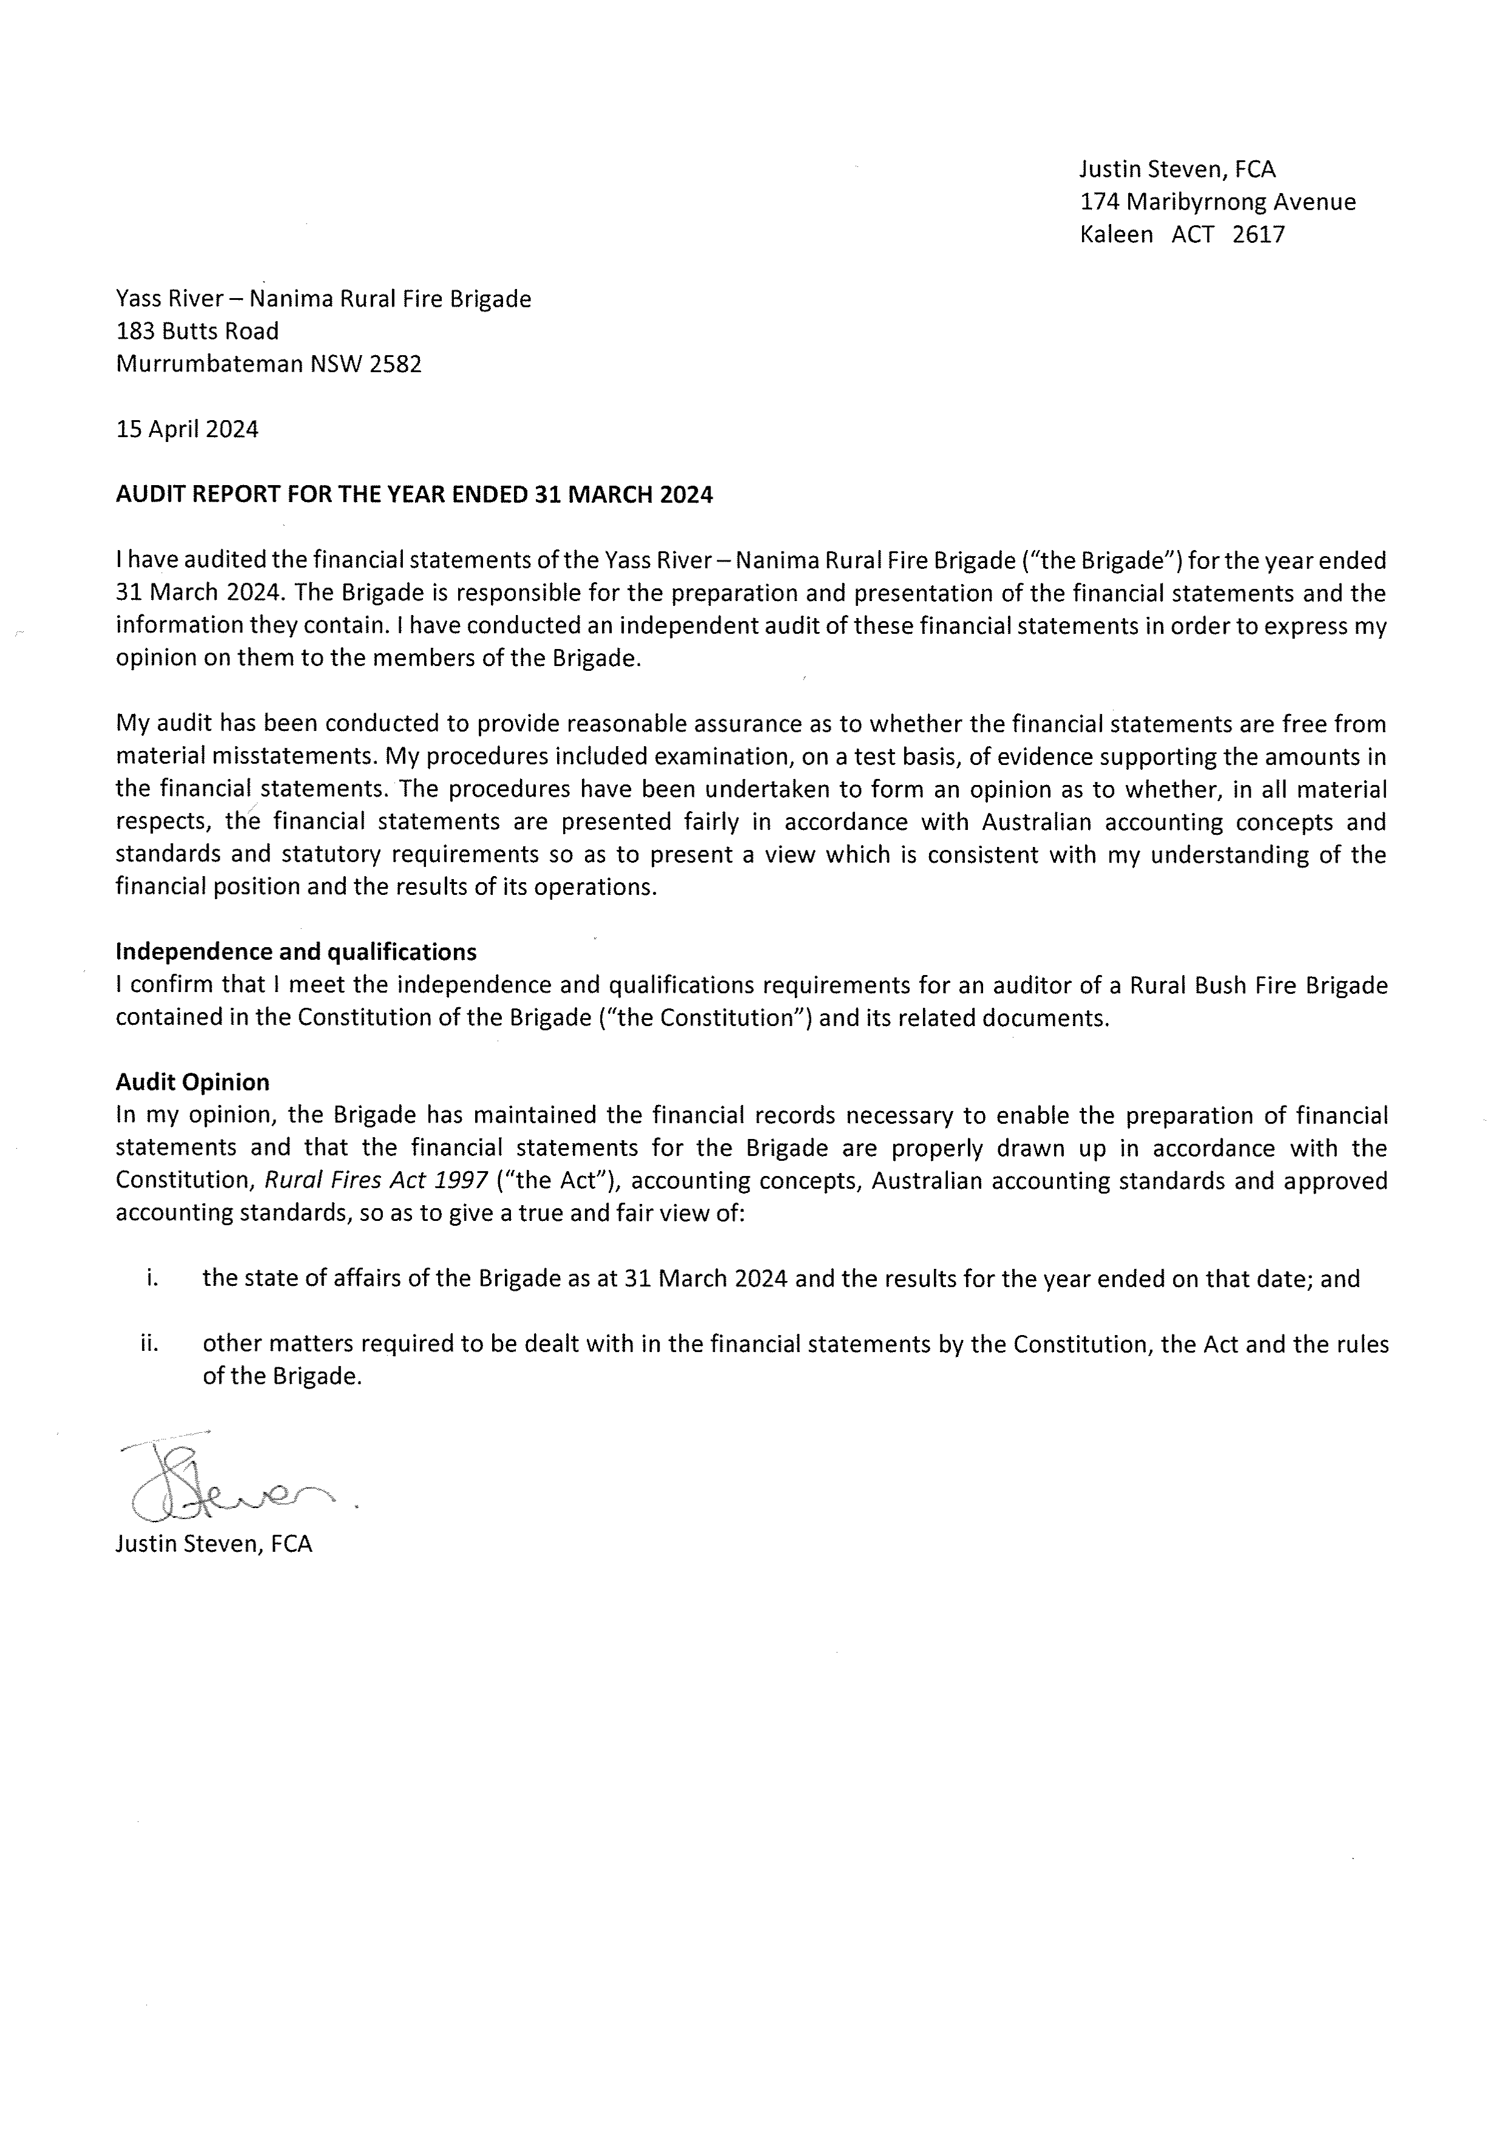

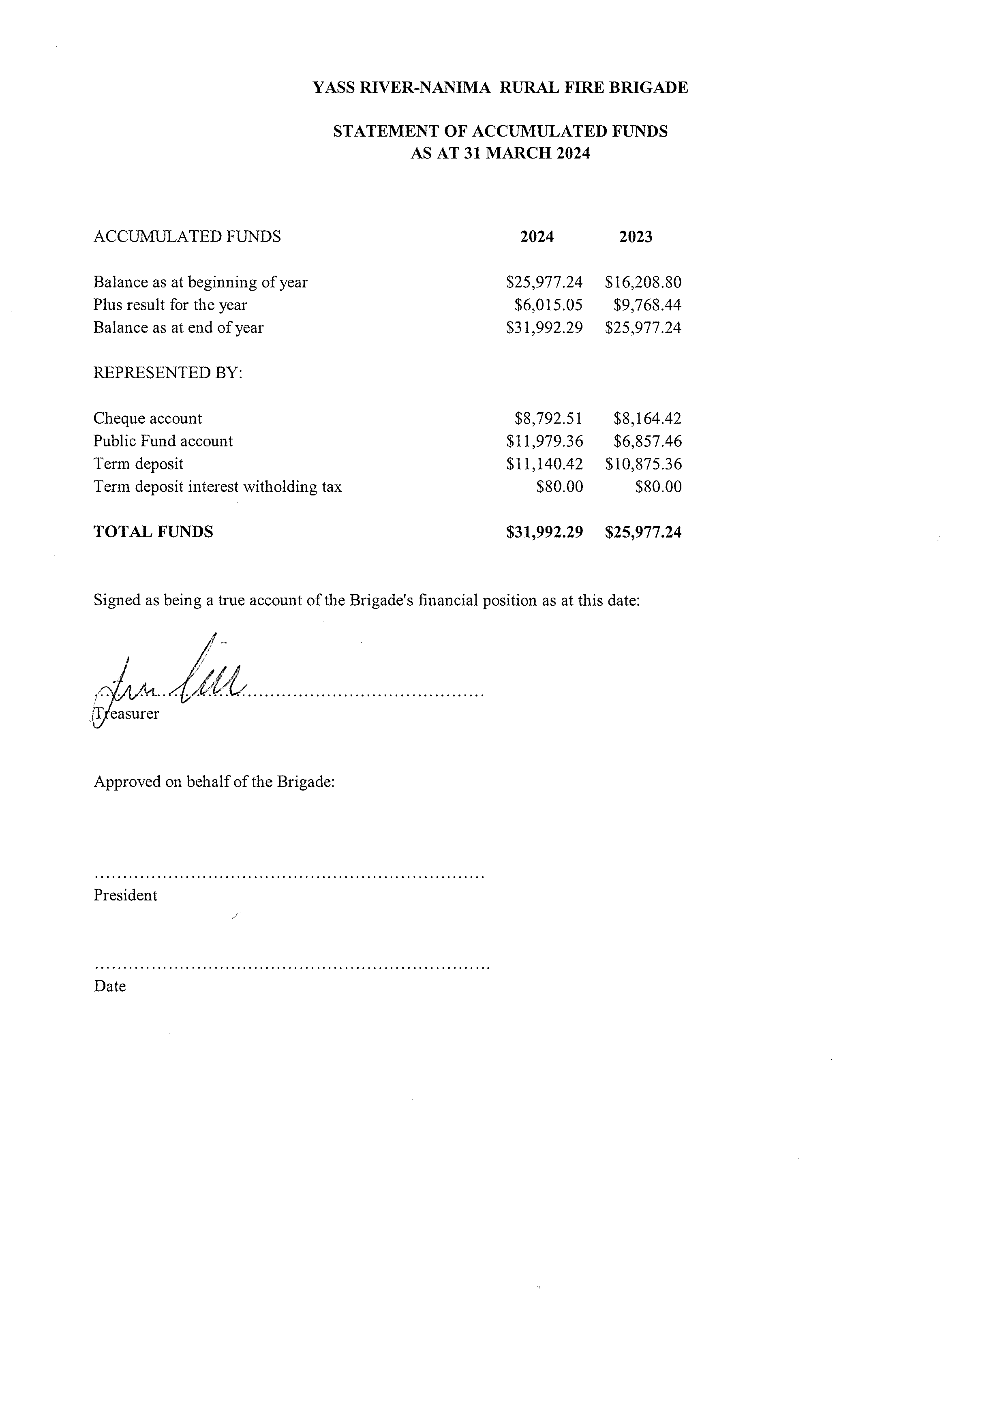
THIS PAGE TO BE REPLACED WITH THE ONE SIGNED BY JUDY

Attachment 5: Catering Officer’s Report

The catering officer’s responsibilities may once have been limited to providing food for firefighters when there was a fire in our own district but these days they are now more broad. The catering officer is engaged to a greater or lesser extent in:
- Maintaining crew snack pack supplies
- Providing training suppers
- Fundraising events (including the Yarrh Solstice, the Field Days, and the Car Boot Sale)
- Social events (the AGM supper and the Christmas party)
- Wildfire catering
- Catering Truck
My role these days has been simply to initiate the volunteer teams. A number of people have taken leading roles in the specific activities:
Snack packs: Rick and Jenny Mumberson have, over the years, assumed responsibility for maintaining the individual crew snack pack supplies in their own time and at their own personal cost (well in excess of the annual donation).
Training suppers: Since retiring from key leadership roles, our truly wonderful life member, Peter Clark, has turned off a lot of training sausages sizzles, more recently yielding the tongs to Andrew Sage but still filling in as needed, and for the past two years, Joanne Byrnes has managed the remainder of the supper items, regularly donating home-cooked fare. She also organised a donation of bulk sausages from the Murrumbateman Butchery.
Fundraising: Caitlin Fillingham and Liz Sage have assisted Fiona with the Yarrh Solstice food for the past several years.
At the inaugural Car Boot Sale, Mark Scott managed the catering, out of the catering truck, with a team comprising Darko Kukic, Rosie Catton and Peter Johnson, augmented by other members when the going got busy. it was a big success.
We also catered for the driver training course weekend that Gareth ran last June. Peter and Rosie, and Darko, with Rick and Patty Duzevic, pulled the two days off with great success.
Social events: Rick has managed the catering service for AGM nights and Christmas parties for some years, with help from others, including Mark Scott. Particular thanks to the key AGM cooks: Fiona Wholohan, Liz Sage and Caitlin Fillingham, and others who provided accompaniments, and to Michael Georgievski for his spit roasting efforts at the Christmas party almost every year since the party was introduced in the noughties.
Wildfire catering: while this is our single most important task, in my period as catering officer we have only been called out to two fires requiring catering. There were none last year.
Catering Truck
It became obvious at the Car Boot Sale that the zone catering truck was in need of some loving attention. Mark Scott worked with the Murrumbateman catering officer to identify the issues, suggest some improvements and develop a catering handbook for the truck.
My thanks to all the people who stepped up. It couldn’t have been done without them.
Volunteers
In addition to those already mentioned, our broader membership and some residents regularly volunteer their time at several of these events each year as part of the full volunteering crew we have needed to make them a success. It couldn’t have been done without them, either.
Field Days team
Of course, one of the fundraising jewels in the crown, sitting beside the Yarrh event, is the Murrumbateman Field Days. This is not a brigade event per se, rather it is a joint Group2/4 event involving 10 brigades in addition to our own. Nevertheless, a preponderance of the management team, led by Kane Fillingham, comes from our brigade. From a catering officer perspective, I am thankful to the close to 25 people who volunteered for a shift last year.
Facilities
Our kitchen facilities are quite basic and it is a credit to our people that they can conjure some great food for our events. We have sought funding for a sandwich maker and coffee machine as part of a larger request for an RFSA grant which, if successful, will make life better for crews that have to stand up at the shed, and possibly other small gatherings.
I have also provided a wishlist to the EC to consider as part of determining our purchase priorities and fundraising target for the upcoming year.

Sally Kaufmann
Catering Officer
Yass River–Nanima Rural Fire Brigade
20 April 2024

Attachment 6: Community Engagement Representative’s Report

In my role as Community Engagement Representative, over the last 12 months, my main objective has been to increase community awareness of the risk of bushfires, how to mitigate those risks and to build community resilience.
Activities associated with this objective include:
- Preparing and delivering farm packs to residents. The packs contained RFS brochures and checklists, Bushfire survival plans, stickers, fridge magnets and kids’ activity packs,
- Organising 3 community notice boards (also a sandwich board) to advertise upcoming events such as Training, Car boot sale and Get Ready Day, The Christmas Party and AGM. These notice boards have been placed in prominent locations on roads within the Yass River–Namina area,
- Consulting with the RFS, stickers (2 styles) were updated and redesigned for members,
- As a member of the team, helped plan and conduct the Car boot sale / Get Ready Day and The Christmas Party,
- Made regular posts on our Facebook page to raise awareness around fire preparedness and brigade events.

Liz Sage
Community Engagement Representative
Yass River–Nanima Rural Fire Brigade
20 April 2024

Attachment 7: Equipment Officer’s Report

This season being quieter than many in recent years meant we had less focus on repairing our four main appliances.
Annual servicing was completed before the warmer weather and we were able to run to ground a problem with the CAT1 pump that had plagued us for the past season or two.
We added some paint to the walls in the shed and are working toward some art work. Replacement of our GPS units in the trucks has started and the introduction of the new Firemapper software is underway.
The Brigade purchased a new Stihl pole saw to assist in track clearing over the off season.
We also have a few grant applications in for more finishings in the fireshed: sandwich maker, coffee machine, mount for TV, and laptops for the captain and secretary.
New handheld radios were also donated to the brigade by “Slabs for Heros” that have replaced our older radios.
We look forward to a quiet off season to continue to improve and add to our inventory, as well as continue maintenance across fleet.

Glenn Odlum
Equipment Officer
Yass River–Nanima Rural Fire Brigade
20 April 2024

Attachment 8: Junior Coordinator’s Report

The brigade has three juniors on the register.
The junior co-ordinator elected at the last AGM stepped back from the role a few months later and I, as captain, stepped into the role by default.
The executive committee is aware there are also a number of prospective juniors in the brigade area and suggests that the incoming committee works actively with the incoming junior co-ordinator to devise a training program more accessible by our current juniors, and develop an engagement strategy to build junior numbers overall.
Our current juniors have participated at brigade activities in recent years, whether or not they were officially members, including helping to build the Yarrh bonfires for the Solstice night celebration and helping on the night as well. They have also been sterling volunteers on our field days’ weekends.

Neville McMartin
Captain & Junior Co-ordinator
Yass River–Nanima Rural Fire Brigade
20 April 2024

Attachment 9: Training Officer’s Report

The brigade had yet another successful year of training encompassing the usual operational months, as well as continued training during the Off-Season. Training took place on the first Tuesday of every month with only one exception, that being January 2024 where training was moved to the second Tuesday in sympathy with the IMSAFER acronym. Training scenarios included, but were not limited to the following:
- Grass fire simulations at various locations within the brigade’s zone of operation;
- Closed CCT relay pumping;
- Drafting from various sources;
- Standpipe familiarization and use at Murrumbateman Rec Grounds;
- Navigation exercises in the greater Yass River area;
- Theory sessions covering such things as grass fires, MVAs, Radio operations, Bush Fire safety 101, etc;
- A brief introduction to MVA’s involving EVs;
- Vehicle equipment familiarisation and operation.
For the most part, member numbers were good, with all three (3) trucks being utilized on most nights, apart from theory sessions, or specific training scenarios.
Training will continue until June initially, and then depending on the consensus of members, continue throughout the Off-Season, or recommence later in the year?

Kim Bannan
Training Officer
Yass River–Nanima Rural Fire Brigade
20 April 2024

Attachment 10: WH&S Officer’s Report

There were three significant WHS issues that arose throughout the past year, otherwise the year has been relatively quiet.
Incidents
I was directed to an RFS member who had experienced an unexpected and confronting incident and may have needed support. I made contact with relatives who advised they would get back to me if needed but was not contacted.
A member suffered a flesh burn to an arm in an apparent ember incident during one of the brigade’s controlled burns last winter. The burn was not serious and was treated by the member. I prepared an incident report and an injury report for the RFS, working with the area WHS officer, Michael Gardiner.
Some weeks later another member found a similar ember burn on the trouser leg of their PPE, with no physical injury sustained. An incident report was submitted to the RFS.
Both sets of damaged PPE were forwarded to RFS engineering for assessment. A report received from the RFS was discussed at training. The report included advice that the affected PPE were sent to the manufacturing company for further evaluation. No report or outcome has been received yet.
We were also advised that any member that has old or damaged PPE get it replaced through the appropriate channels and paperwork.
Breathing masks
A review of the cleaning procedure required to ensure the hygiene of the reusable breathing masks in the trucks is not complete, but I am starting to come to the opinion that an effective procedure may require hours to complete and is not feasible for a system that requires the masks to be retained in the trucks.
If the cleaning process required to keep these masks hygienic from one user to the next is not reasonable, one solution may be that the brigade purchases enough masks to issue one to each member as part of PPE.
The quiet fire season has meant that an assessment of the individual RFS-supplied reusable breathing masks, including a type that we obtained some time ago and initially dismissed, has not been completed.

Darko Kukic
WHS officer
Yass River–Nanima Rural Fire Brigade
20 April 2024

Attachment 11: Proposal to Remove 4 members from the Register

At the executive committee meeting of 27 May 2023, the committee agreed to seek the membership’s approval to remove the following 4 members from the register:
- Paul Butt
- Carmela Fearnside
- Carlton Fearnside
- Daryl Milton
The EC took this decision on the basis that the members are known to have left the district and have had no contact with the brigade for some years.
In regard to Paul Butt, the decision was taken with particular regret. Our preference would have been to seek his agreement to move him to associate member status. Unfortunately, the brigade has lost touch with Paul since he moved out of the district, so this option was not possible.
Paul joined the brigade on 1 January 1964, only seven years after it was formed, at the age of 15. He was a stalwart and devoted member of the brigade for decades, including serving as deputy.
Given the reasons for removal and the desirability of maintaining a streamlined register (on which the ACTIV listing is based), the RFS implemented these changes based on the EC’s 27 May decision, in expectation of endorsement at this AGM. This proposal is to complete the formal removal process.

Sally Kaufmann
Secretary
Yass River–Nanima Rural Fire Brigade
20 April 2024

Attachment 12: Proposal to increase the size of the EC to 5

At last year’s AGM it was decided to limit the executive committee to the four positions of captain, president, treasurer and secretary, a quite significant shift from the 13 or so committee members of previous years.
After a year of operation, the committee is of the opinion that this is now too small a number, with too few people to take on the work that arises and creating additional difficulties in the extended absence of any member.
To overcome this problem, the committee proposes that the executive committee be increased to 5 by:
a) amending Rule 12, Additional Administrative Officers, to add the position of vice-president to the list of office-bearers to be elected at the AGM, and
b) amending Rule 14, Additional Members of the Executive Committee, to add the position of vice-president to the executive committee.

Sally Kaufmann
Secretary
Yass River–Nanima Rural Fire Brigade
20 April 2024

Attachment 13: Agenda
NOTE: The numbering of the items at the bottom of the agenda as distributed was corrupted. The order remained the same
AGENDA
ANNUAL GENERAL MEETING
20 April 2024, 6pm
To be held at the Fireshed, 322 Greenwood Rd, Murrumbateman

1 Meeting open
2 Determination of Quorum
3 Apologies
4 Declaration of Proxies
5 Acceptance of previous minutes
Annual General Meeting held 29 April 2023
6 Business arising from previous minutes
7 Annual reports
- Captain
- President
- Treasurer
- Catering officer
- Community Engagement Officer
- Equipment Officer
- Junior Co-ordinator
- Training Officer
- Work, Health & Safety Officer
8 Membership Matters
Including a proposal to remove four members from the register
9 Constitution Review
Proposal to increase the size of the executive committee to five.
9 Determination of number of deputies for the upcoming year
15 Appointment of a returning officer
16 Elections
Nominations will be called for and elections held to fill the following positions:
- Captain
- President
- Secretary
- Treasurer
- Senior Deputy
- Deputy captains, number as determined at Item 10
- Catering Officer
- Community Engagement Representative
- Equipment Officer
- Junior Co-ordinator
- Training Officer
- Work, Health & Safety Officer
- Any position determined at item 9
18 Donation in lieu of a membership fee
19 Other Business
20 Next meeting
20 Close

Sally Kaufmann
Secretary
29 March 2024

